**Project Design Phase-II**

**Technology Stack (Architecture & Stack)**

| Date | 03 October 2022 |
| --- | --- |
| Team ID | PNT2022TMID43213 |
| Project Name | Project - Real-Time Communication System Powered by AI for Specially Abled |
| Maximum Marks | 4 Marks |

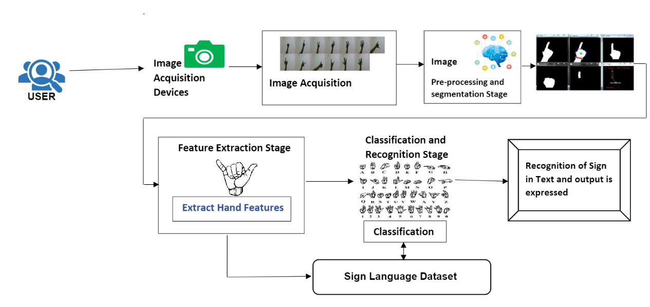

**Table-1 : Components & Technologies:**

| **S.No** | **Component** | **Description** | **Technology** |
| --- | --- | --- | --- |
|  | User Interface | Customer have to login giving their all required information, then interaction will happen with the user interface. | HTML, CSS, JavaScript / Angular Js / React Js etc. |
|  | Application Logic-1 | it requires various types libraries,frameworks to develop the project | Java / Python |
|  | Application Logic-2 | helps to converting the human gesture/actions into written words | IBM Watson STT service |
|  | Application Logic-3 | Provides helpful,feasible answer after recognising the human gestures | IBM Watson Assistant |
|  | Database | Data could be numbers or words | MySQL, NoSQL, etc. |
|  | Cloud Database | Providing customer to use host database without buying additional hardware. | IBM DB2, IBM Cloudant etc. |
|  | File Storage | File storage could be fast,reliable and flexible | IBM Block Storage or Other Storage Service or Local Filesystem |
|  | External API-1 | used to access the information in the cloud | IBM Weather API, etc. |
|  | External API-2 | used to access the information for data driven decision making | Aadhar API, etc. |
|  | Machine Learning Model | Purpose of Machine Learning is to interact with various algorithms that are required for implementation. | Object Recognition Model, etc. |
|  | Infrastructure (Server / Cloud) | Application Deployment on Local System / Cloud  Local Server Configuration. | Local, Cloud Foundry, Kubernetes, etc. |

**Table-2: Application Characteristics:**

| **S.No** | **Characteristics** | **Description** | **Technology** |
| --- | --- | --- | --- |
|  | Open-Source Frameworks | frameworks used | Tensorflow,Theano,RNN,PyTorch |
|  | Security Implementations | the security / access controls implemented | Firewall and some security related softwares. |
|  | Scalable Architecture | the scalability of architecture | Data, models, speed and consistency |
|  | Availability | the availability of application | Image recognition,sign/gestures recognition, text recognition & real time captioning |
|  | Performance | Design consideration for the performance of the application | USing Convolutional neural network, machine learning for conversation and improve the sensitivity of the performance. |